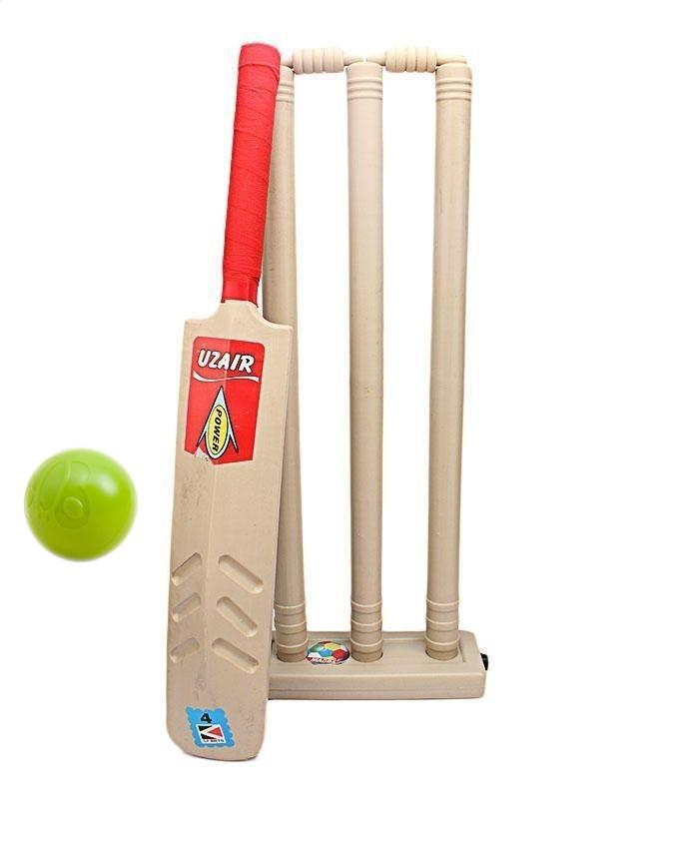Cricket Bat Cricket Ball with Wicket Set For Kids

Rs. 379

~~Rs. 700~~-46%

Set For Kids - 18 Inches Children's Plastic cricket balls playing Set sports toys

* This bat is suitable for players that like to dominate at the crease. It is ideal to play for your kids. Gives you the best batting experience with high swell position, super concave profile & toe. The light weight design gives you a firm grip and more control on your strokes. The wicket features three stumps fixed on a wooden stand. Attached with a quality spring that returns the vertical position of stumps after being hit by ball. Suitable for indoor cricket Get this today and be the cricket star